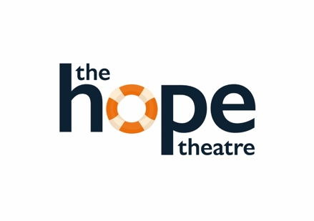
Submissions Form
BE HEARD
Monologue Writing Competition

Name of entrant:_________________________________________________________

Age category:
*Entrants age must be within the age category ticked below on 15 September 2020.

11 – 13 years 14 – 17 years 18 – 25 years

Title of monologue:_______________________________________________________

Contact details:
*If the entrant is under 16 years, please provide the contact details of a parent/ guardian/ teacher with their permission.

Address:_________________________________________________________________

_________________________________________________________________________________

Email address:____________________________________________________________

Mobile/phone number:__________________________________________________________

I have read and understood the full terms and conditions and can confirm that this is an original monologue that has not been performed or produced. I confirm that I am over 16 years of age or have parental permission to enter.

Signature of entrant:__________________________________________________________

Signature of adult submitting on behalf of a child of 16 years or below.

_________________________________________________________________________

*Please make sure you attach this page with your separate entry via email to info@thehopetheatre.com.

